Deploy an application

- Kubernetes is designed to help make your applications highly available, meaning there are multiple replicas of your application running at the same time, so that if one stops working, there are at least two others accepting traffic. Pods are the Kubernetes resource that run our applications and microservices, and one way to ensure that an application is highly available is to organize your Pods using a Kubernetes deployment.

Example deployment.yaml:

---

apiVersion: apps/v1

kind: Deployment

metadata:

  name: pod-info-deployment

  namespace: development

  labels:

    app: pod-info

spec:

  replicas: 1

  selector:

    matchLabels:

      app: pod-info

  template:

    metadata:

      labels:

        app: pod-info

    spec:

      containers:

      - name: pod-info-container

        image: kimschles/pod-info-app:latest

        ports:

        - containerPort: 3000

        env:

          - name: POD_NAME

            valueFrom:

              fieldRef:

                fieldPath: metadata.name

          - name: POD_NAMESPACE

            valueFrom:

              fieldRef:

                fieldPath: metadata.namespace

          - name: POD_IP

            valueFrom:

              fieldRef:

                fieldPath: status.podIP

kubectl get ns

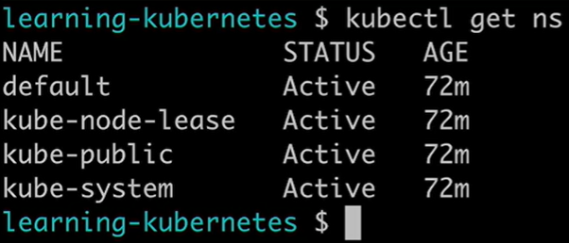

run the apply command on the namespace.yaml file.

**kubectl apply -f namespace.yaml**

Looks like we're ready to go. Now, let's create the deployment. Run the command

**kubectl apply -f deployment.yaml**

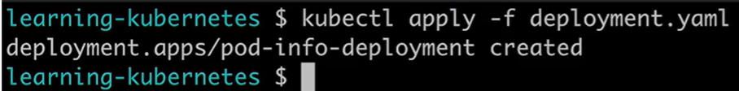

Let's confirm by listing all the deployments in the development namespace with the command "**kubectl get deployments -n**" for namespace "**development**".

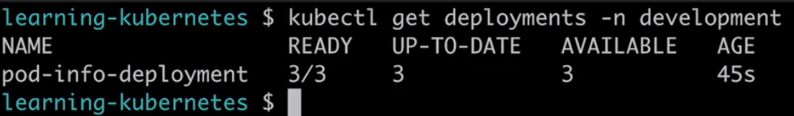

There's the deployment we named in the YAMIL Manifest, pod-info-deployment, and there are three containers ready to go, up to date and available. Finally, let's see the Pods that the deployment created. Run "**kubectl get pods -n development**".

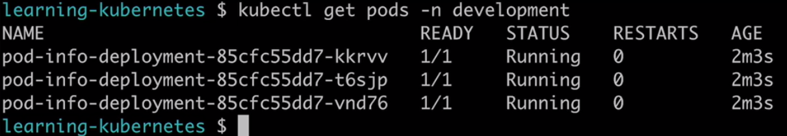

If I delete a pod, it creates a new one maintaining the 3 pods stated.

kubectl delete pod <hash> -n

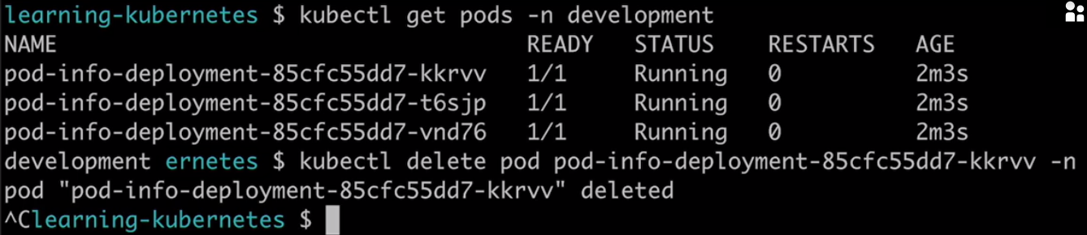

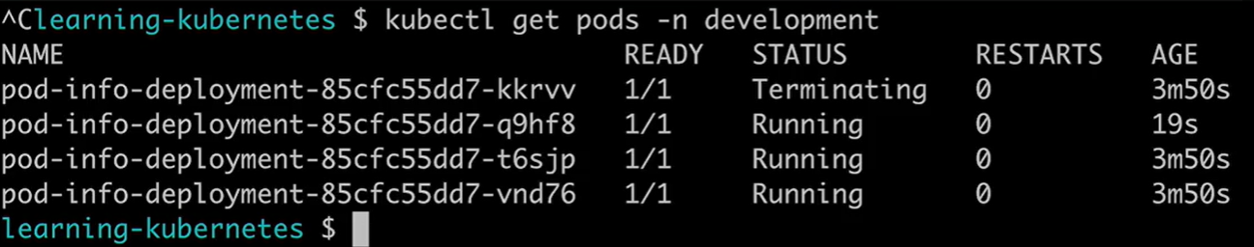

See logs of the pod.

Run **kubectl describe pod <hash> -n development**

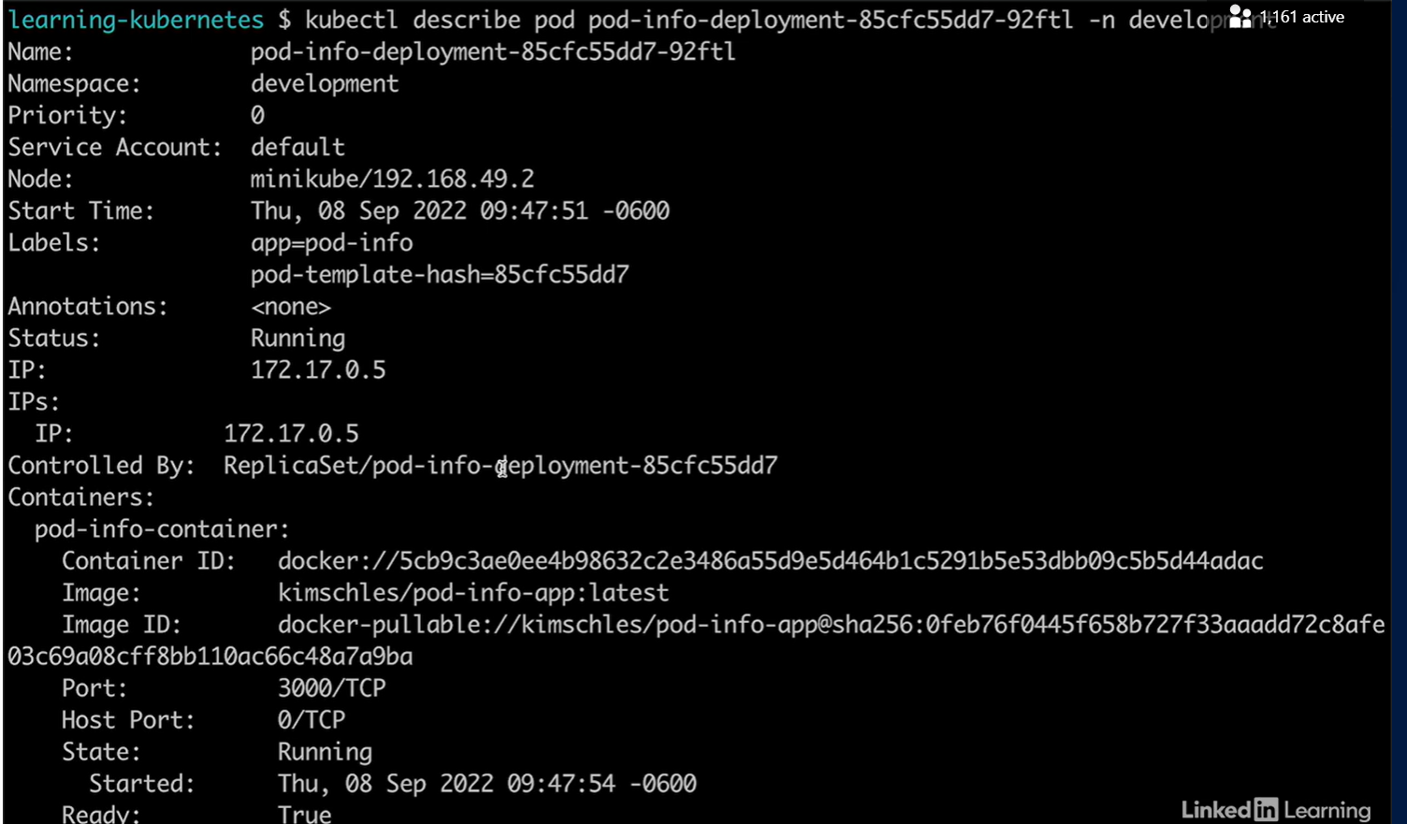

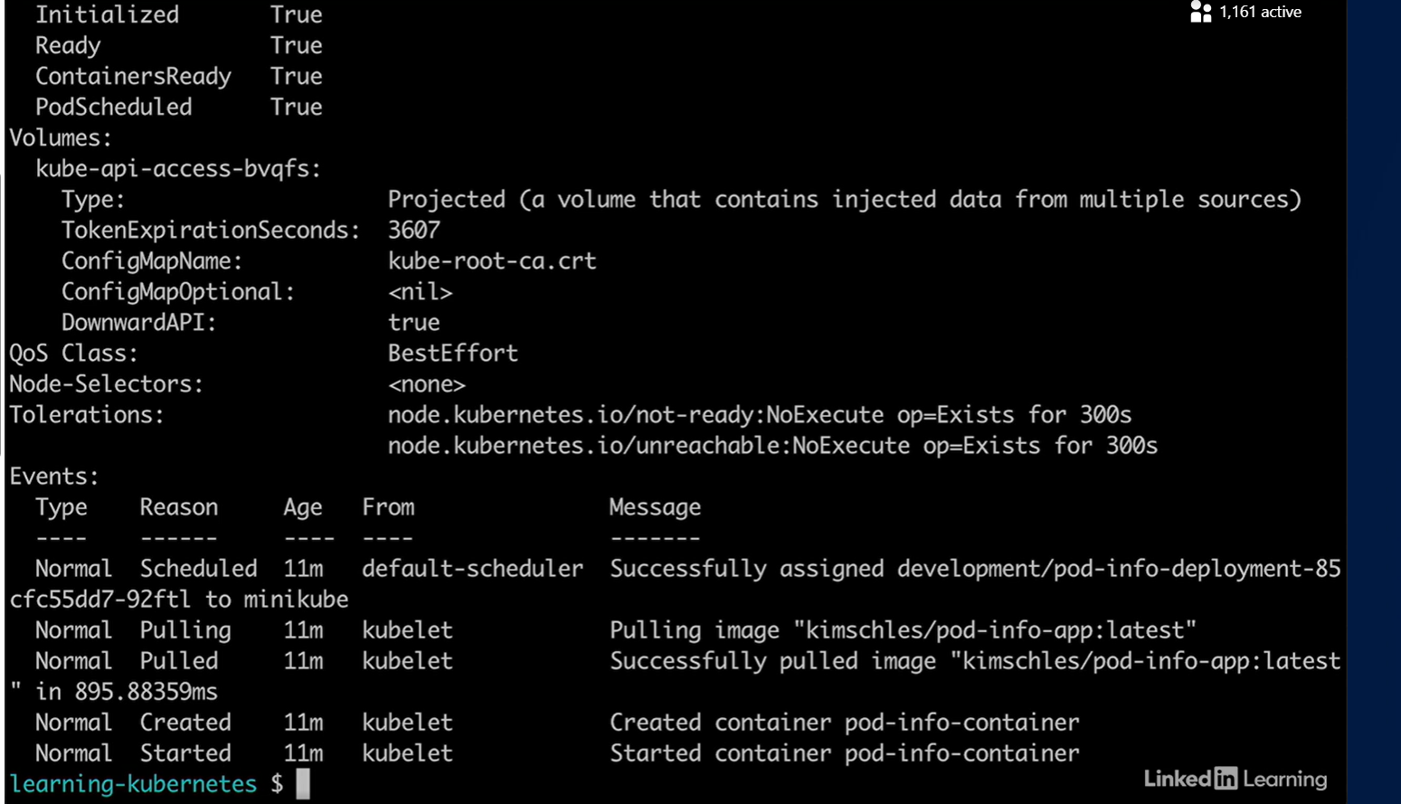

To see the event logs, let's scroll down to the bottom. If your pod is running and healthy, you'll see messages like this. If your pod is having issues, you'll see log messages that can help you identify the problem by showing you an error. If your pod has been up and running for a while, when you check the event logs, you'll see none. That means that Kubernetes is letting the pod do its own thing, because it's healthy. Most issues with pods occur in the first minute of their life cycle.

To verify that the application is working, you can use BusyBox

It's a good tool for debugging and troubleshooting issues in a Linux environment and Kubernetes runs on Linux. Let's create a pod running BusyBox. First, find and open the BusyBox dot YAML file.

---

apiVersion: apps/v1

kind: Deployment

metadata:

  name: busybox

  namespace: default

  labels:

    app: busybox

spec:

  replicas: 1

  selector:

    matchLabels:

      app: busybox

  template:

    metadata:

      labels:

        app: busybox

    spec:

      containers:

      - name: busybox-container

        image: busybox:latest

        # Keep the container running

        command: [ "/bin/sh", "-c", "--" ]

        args: [ "while true; do sleep 30; done;" ]

        resources:

          requests:

            cpu: 30m

            memory: 64Mi

          limits:

            cpu: 100m

            memory: 128Mi

Unlike our other deployment, we're going to deploy this in our default namespace and run only one replica. Let's create the BusyBox pod with

**kubectl apply -f busybox.yaml**

Let's check and see that the BusyBox Pod is up and running with the command

**kubectl get pods**

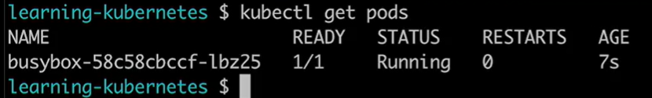

I didn't specify a name space, which is fine because if you don't, kubectl assumes you want the objects in the default name space. We want to use BusyBox to make an HTTP get request to our application, and we need to know the IP address of our pods in order to make that request.

In another terminal run:

**kubectl get pods -n deployment -o wide**

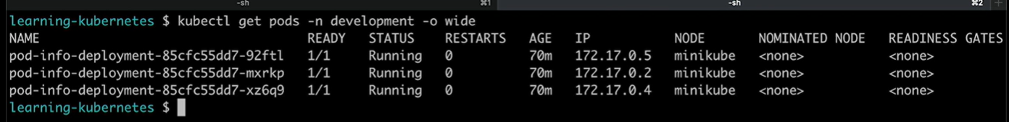

We need to get inside our BusyBox pod so we can use the Wget tool to make an HTTP request. We're going to use a kubectl command called Exec, which allows us to run commands in a container.



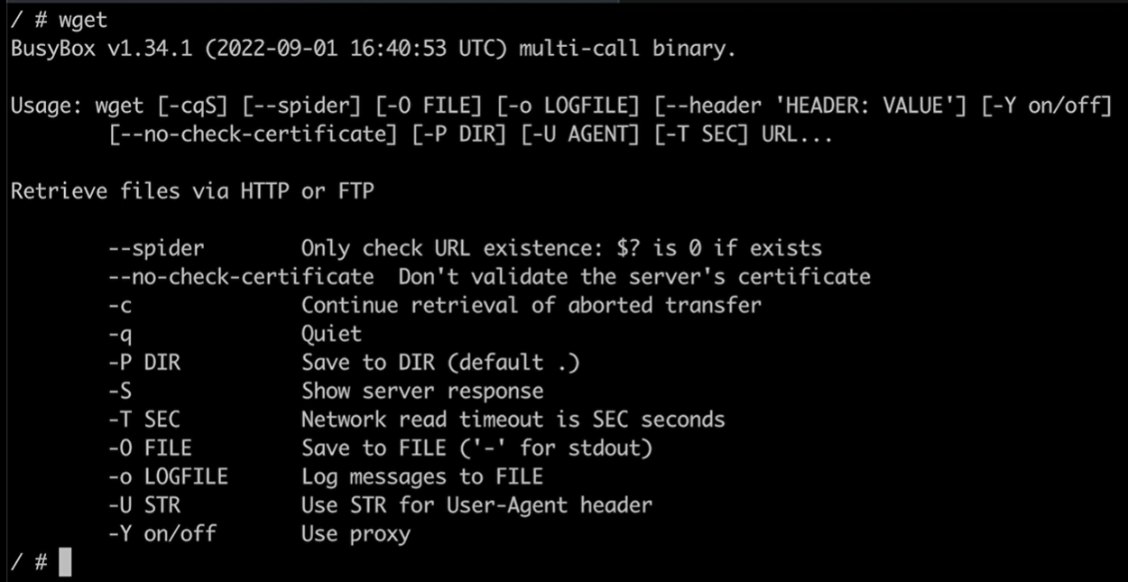

copy the IP address for one of the pods.

Then go to the BusyBox pod and run wget <IP_address>. We're getting an error that says, "Wget Can't connect to remote Host connection refused." If I look at the line above, in the parenthesis I see the pod IP address in port 80, the default port.

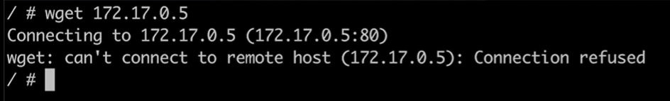

Let's look at our original deployment. Remember, when we created this deployment, we set up the pod's container to use Port 3000. So, let's rerun that wget command and add Port 3000 at the end of the IP address.

**wget 172.17.0.5:3000**

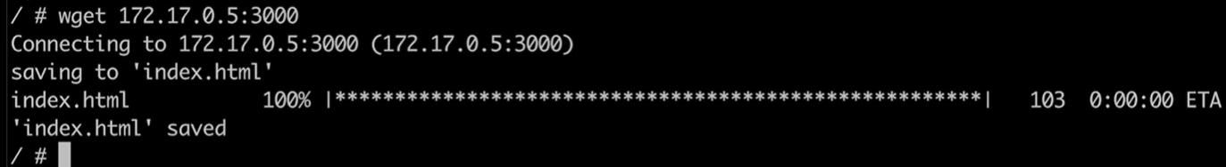

It looks like it worked. And that wget saved that info in a file called index.html.



If your application is deployed in a cluster but not yet exposed to the internet, how do you check that it's working? One way is to spin up a BusyBox pod, find a pod's IP address and use Wget to make a get request so you can verify that your application is working.

See your application logs:

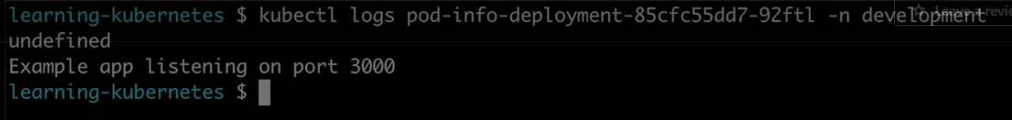

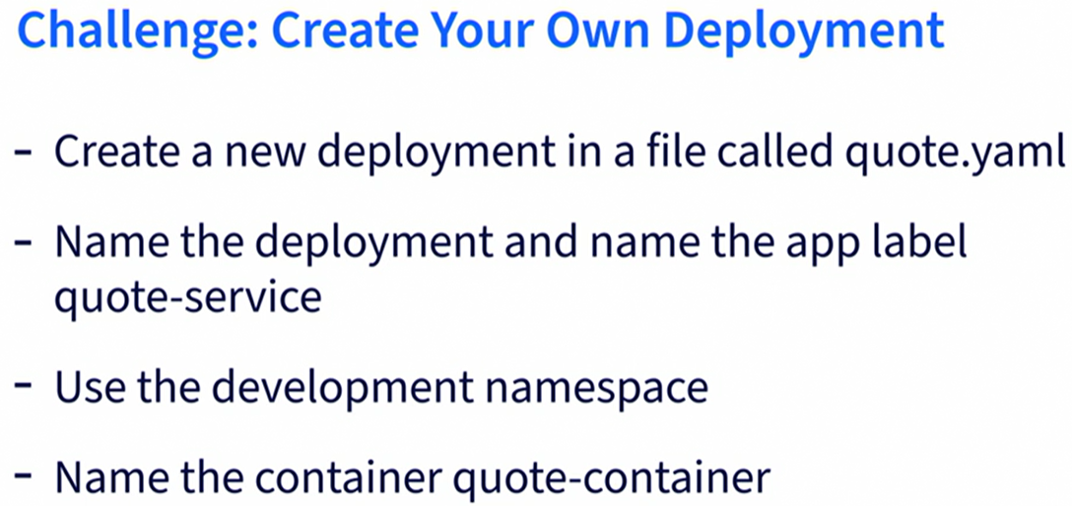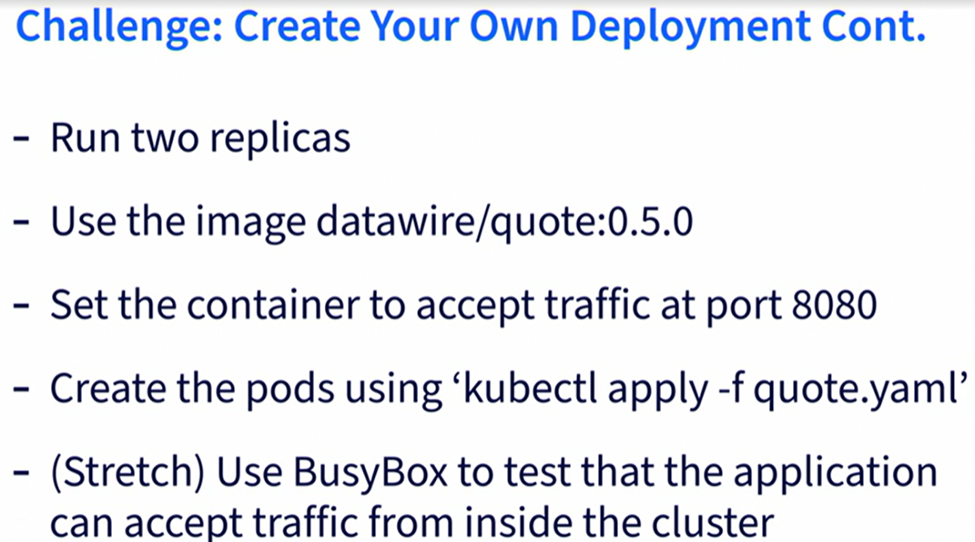

Create the file quote.yaml

---

apiVersion: apps/v1

kind: Deployment

metadata:

  name: quote-service

  namespace: development

  labels:

    app: quote-service

spec:

  replicas: 2

  selector:

    matchLabels:

      app: quote-service

  template:

    metadata:

      labels:

        app: quote-service

    spec:

      containers:

      - name: quote-container

        image: datawire/quote:0.5.0

        ports:

        - containerPort: 8080

Create the pod

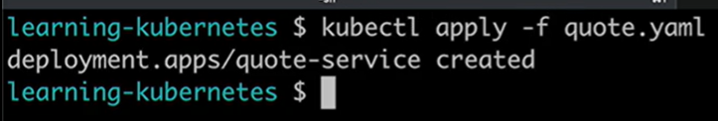

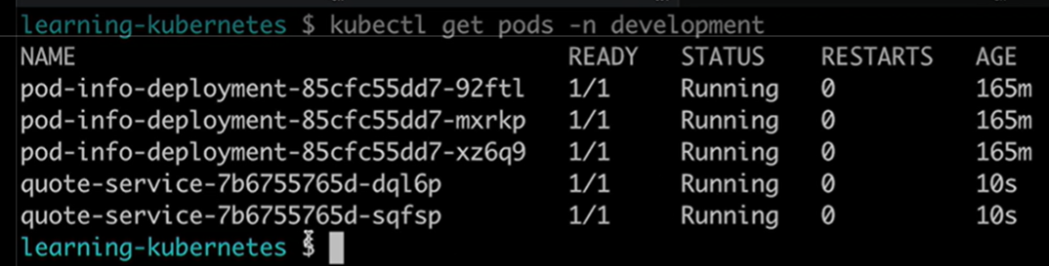

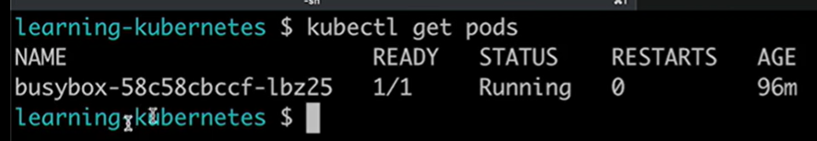

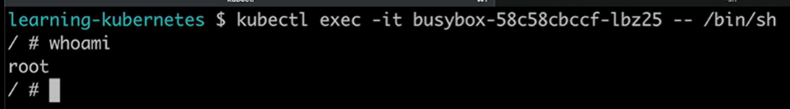

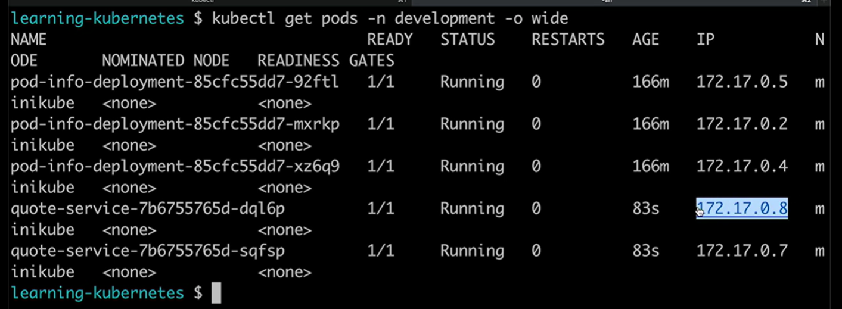

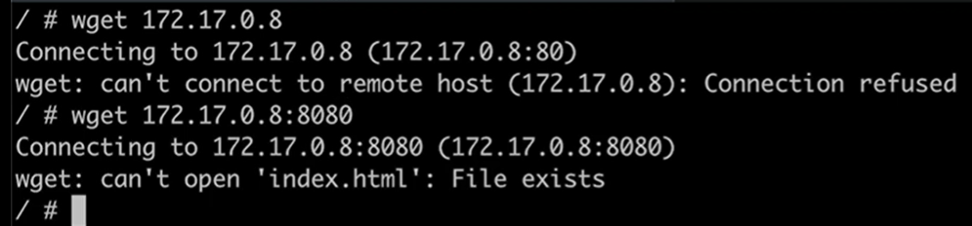

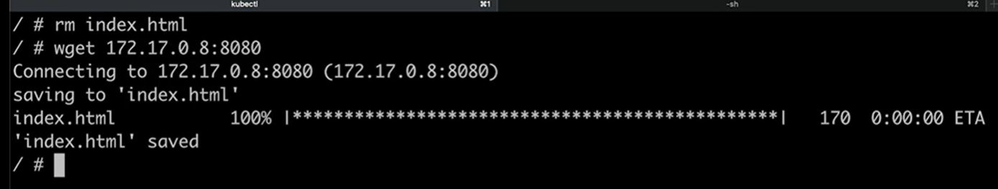

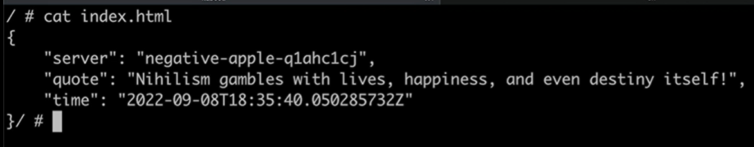

**Expose the application to the internet with a LoadBalancer**

How do you expose your application to the internet? The answer is called a Kubernetes service. A Kubernetes service is a load balancer that directs traffic from the internet to Kubernetes pods. A load balancer service has a public and static IP address. The public IP address means that anyone can access it from the internet, and the static part is important because your pods and their IP addresses change frequently, but your service IP needs to remain the same. Let's take a look at a .yaml manifest for a service. We're going to create a service called demo-service in the development namespace.

The next part is really important. We have the selector map and we're telling the service it should send traffic to any pods with the label app: pod-info Let's look back at our deployment spec. Here, we made sure any pods created by this deployment have that label. If these things don't match, your service won't be able to direct traffic to your pods. Back to the service.yaml. In the port sequence, we're setting the services port to 80. That's the default, so you don't have to type in the port number in a URL, but the service is directing traffic to port 3000 in our container. Finally, we're specifying that the service type is a load balancer. This is one of three types of Kubernetes services. The other two are node port and cluster IP. Let's create this service.

---

apiVersion: v1

kind: Service

metadata:

  name: demo-service

  namespace: development

spec:

  selector:

    app: pod-info

  ports:

    - port: 80

      targetPort: 3000

  type: LoadBalancer

Open a separate tab and run the command,

minikube tunnel

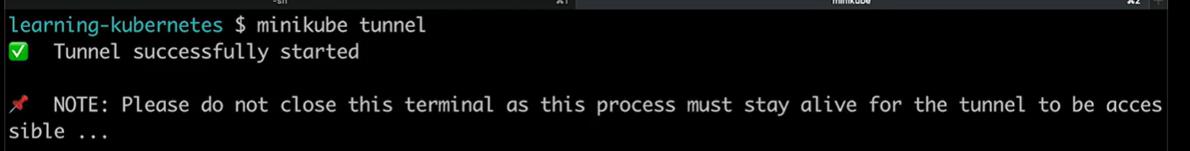

In another terminal run:

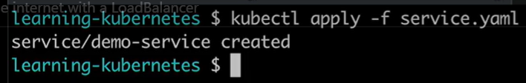

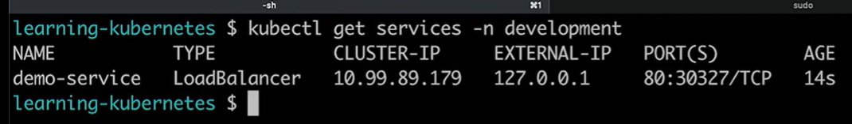

We see our demo service and it has two IP addresses, one for inside the cluster and one external IP. Side note, for those of you with a keen eye, you may have noticed that our "external IP address" is actually the IP address for our local host, 127.0.0.1. Because minikube works only in our computer and not in a public cloud, we're not actually getting an IP address available on the internet. If you create a load balancer service with Google Cloud, Azure, AWS, or any other cloud provider, they'll give you a public IP address available on the internet. Let's try and access our application from that IP address.

Open the browser to open the 127.0.0.1, maybe a password is required in the minikube tunnel:

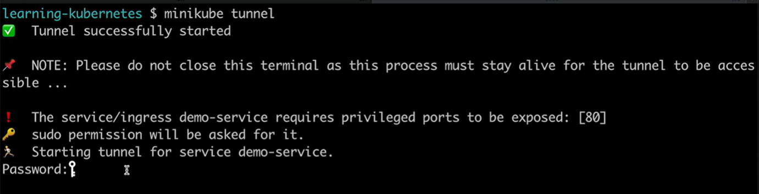

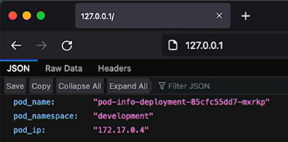

**Add resource request and limits to your pod**

Resources refer to the amount of available CPU and memory on the worker node running your pods. If you deploy a pod without a set of resource requests, it can be scheduled on a node that does not have enough processing power or memory and cause the node to fail. Similarly, if you deploy a pod without a set of resource limits, you can start a pod on a node, but if the application begins using more and more CPU or memory, it can use all those resources on the node causing it to fail. Failed nodes can cause outages, which you want to avoid. Let's add resource request and limits to our pod info.

We can go to the documentation to see examples:

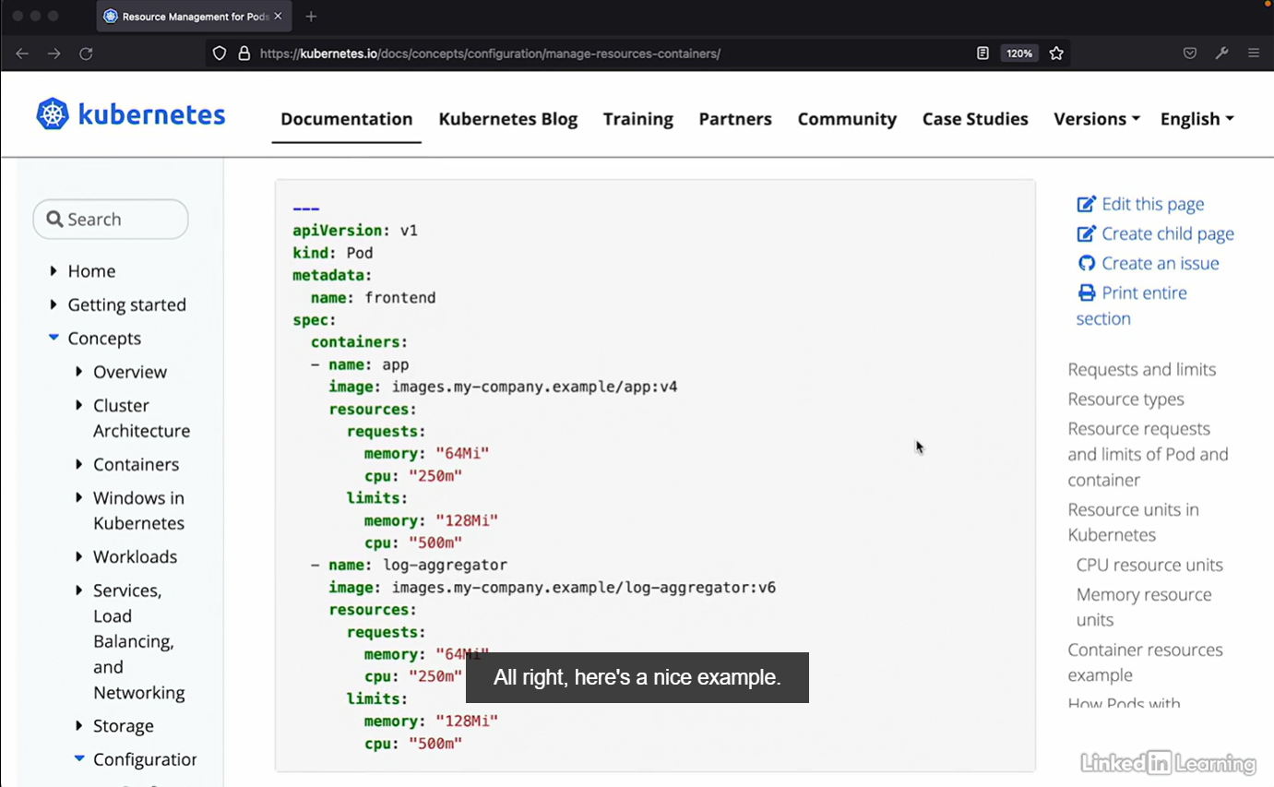

Lets update our yaml.

---

apiVersion: apps/v1

kind: Deployment

metadata:

  name: pod-info-deployment

  namespace: development

  labels:

    app: pod-info

spec:

  replicas: 1

  selector:

    matchLabels:

      app: pod-info

  template:

    metadata:

      labels:

        app: pod-info

    spec:

      containers:

      - name: pod-info-container

        image: kimschles/pod-info-app:latest

        resources:

          requests:

            memory: "64Mi"

            cpu: "250m"

          limits:

            memory: "128Mi"

            cpu: "500m"

        ports:

        - containerPort: 3000

        env:

          - name: POD_NAME

            valueFrom:

              fieldRef:

                fieldPath: metadata.name

          - name: POD_NAMESPACE

            valueFrom:

              fieldRef:

                fieldPath: metadata.namespace

          - name: POD_IP

            valueFrom:

              fieldRef:

                fieldPath: status.podIP

Let's just make sure that looks right. Looks good to me. All right, we've set resource request and limits for our pod info container. Let's look in the resources sequence. We have a request section saying that do not schedule this pod unless the node has at least 64 mebibytes of memory and 250m of CPU. On the other hand, we have the limit section which says, stop running this container if it exceeds using 128 mebibytes of memory and 500m of CPU. You're probably wondering how you decide on the values for the requests and limits. The answer is it depends on the container you're running in the pod.

To update our pod, run: **kubectl apply -f deployment.yaml**

**Delete cluster**

It's best to clean up your cluster and stop it when you're not using it. The first thing we want to do is delete any Kubernetes resources we created. We'll do that using the YAML files. Here's a list of files that we used. We can delete the objects in these files by running:

**kubectl delete -f** <file_name>

I'm going to go through and do that one by one.

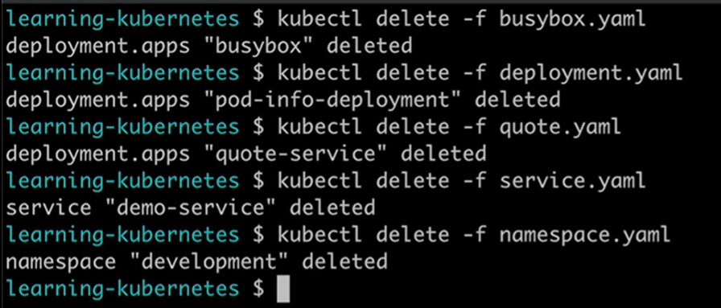

Make sure you delete the namespace last because it will destroy anything inside of it when it is deleted. You could also do it first if you only want to run one command. Finally, let's delete our minikube cluster. The command is simple, minikube delete.

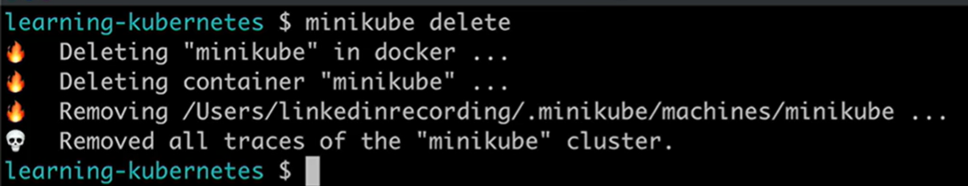

When you want someone to access an application deployed in your Kubernetes cluster, you will set up a Kubernetes LoadBalancer Service.

**The Kubernetes control plane**

Let's learn some important vocabulary. An instance of Kubernetes is called a cluster, and each cluster has a control plane and at least one worker node.

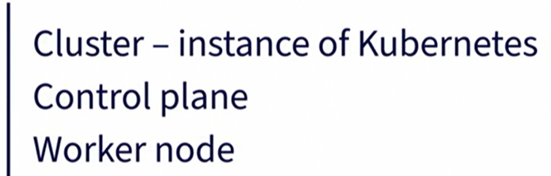

If Kubernetes is like an airport, the control plane is like the air traffic control tower with people overlooking the cluster and making sure nodes and pods are created, modified, and deleted without any issues.

The control plane is made up of several components.

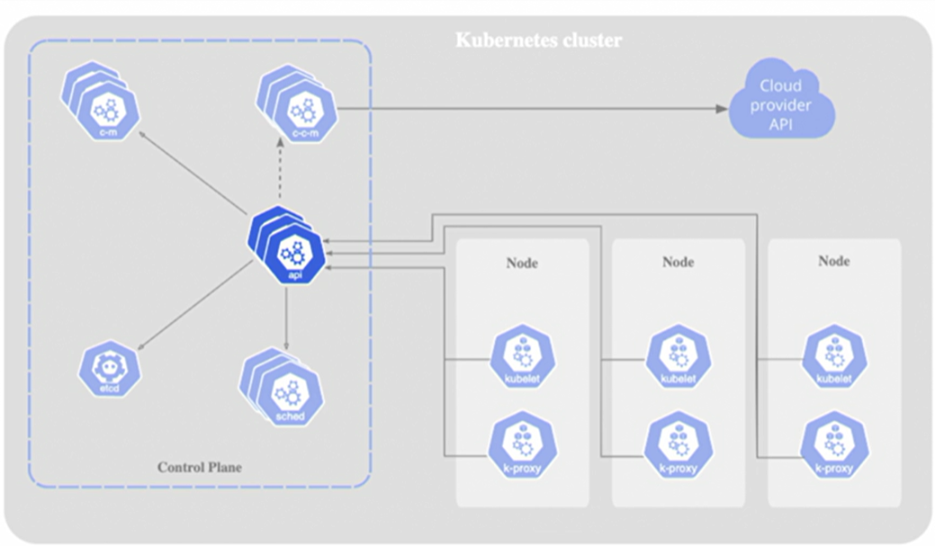

The first and most important control plane component is the Kube API Server. The API server exposes the Kubernetes API.

* Each Kubernetes object like pods, deployments, and the horizontal pod autoscaler have an API endpoint.
* The Kubernetes API has a REST interface and,
* kubectl and kubeadm are the command line tools that let us communicate with the Kubernetes API via HTTP requests.

To see all the Kubernetes objects and their API version, run the command **kubectl api-resources**. You'll see a longer version of this table.

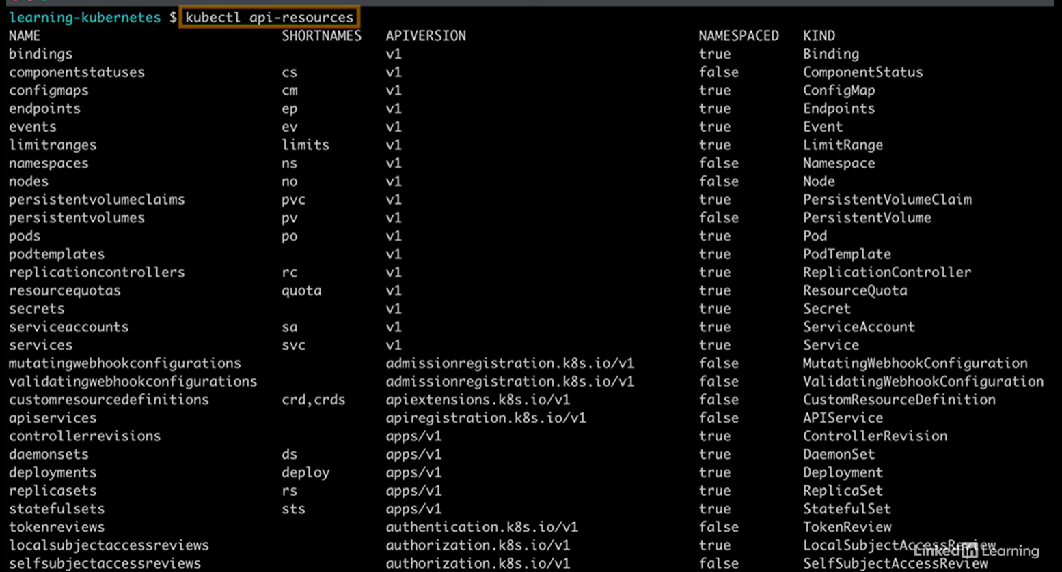

Like all things in Kubernetes, the Kube API server is a containerized application run as a pod and you can see it by listing all pods running in the kube system name space with the command **kubectl -n kube-system get pods**.

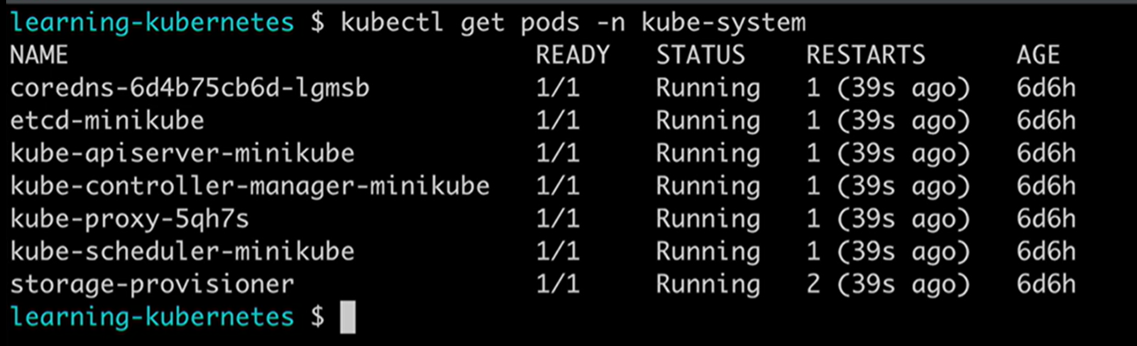

The pod has kube dash API server at the beginning of the name. The kube API server is the Kubernetes component that handles the most request from the user and inside the cluster and without it, a Kubernetes cluster cannot exist.

The next component of the Kubernetes control plane is etcd. Etcd is an open-source, highly available key value store, and in a Kubernetes cluster, it saves all data about the state of the cluster. Only the Kube API server can communicate directly with etcd. Etcd is also run as a pod and you can look at the logs to get a sense of how etcd works. Find the etcd pod in the kube system namespace, copy the name of the pod, and then run the logs command to see etcd's most recent operations.

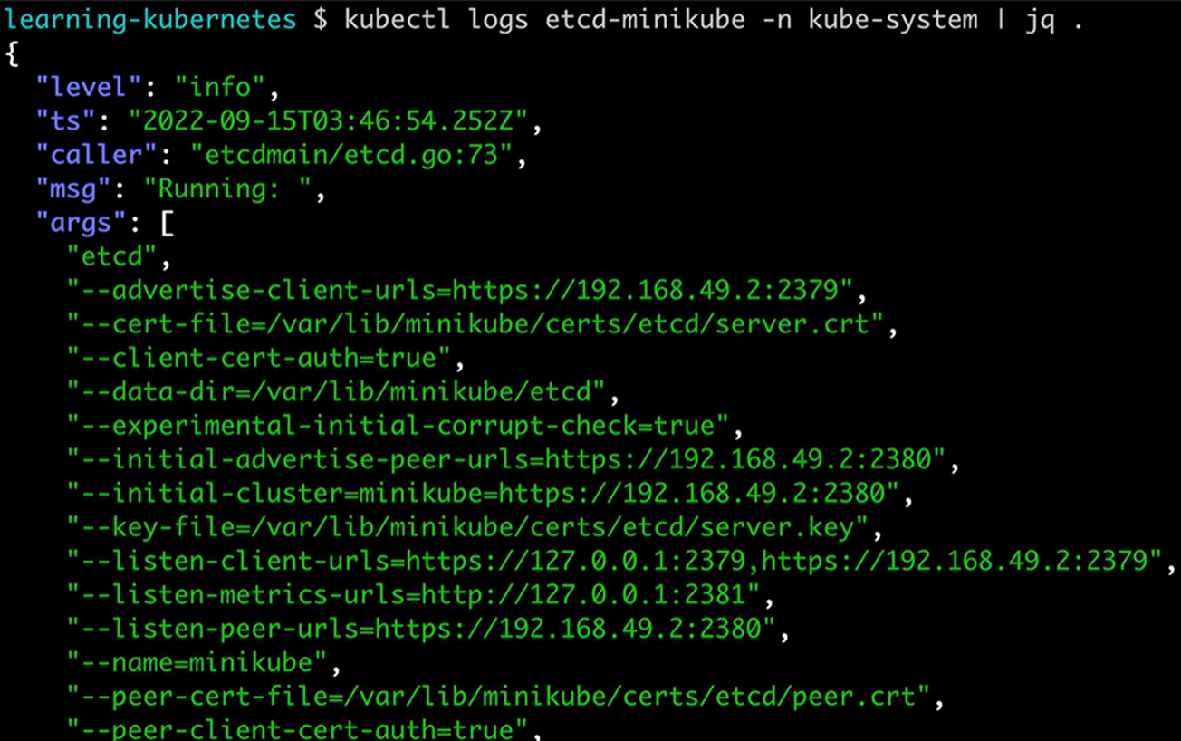

The next component is the kube scheduler, which identifies newly created pods that have not been assigned a worker node and then chooses a node for the pod to run on. Like the prior components we covered, the kube scheduler is run as a pod, and you can learn more about it by describing the pod or inspecting its logs.

The next component is the Kube-controller-manager. The controller manager is a loop that runs continually and checks the status of the cluster to make sure things are running properly. For example, the controller manager checks that all worker nodes are up and running, and if it finds that something is broken, it will remove the broken node and replace it with a new worker node. The controller manager creates and checks several other things in a cluster.

The final component of the Kubernetes control plane is the cloud controller manager, which lets you connect your cluster with a cloud provider's API so you can use cloud resources from AWS, GCP, Azure, or any public cloud.

The Kubernetes control plane contains the components that manage a cluster and enable the resiliency and automation that make Kubernetes such a popular container orchestrator. One note, if you're using a managed Kubernetes service like AWS's EKS or Google's GKE, you will not be able to see your control plane nodes using kubectl, those are hidden because the cloud provider handles all the maintenance of those components for you. In our next video, we'll learn about the second part of a cluster, the worker.

**Kubeernetes worker nodes**

If Kubernetes is like an airport, the control plane is like the air traffic control tower, and the worker nodes are like the busy terminals, where planes park and passengers board. To be highly available, most Kubernetes clusters run with a minimum of three worker nodes.

The worker nodes are where pods are scheduled and run, and each worker node has three components.

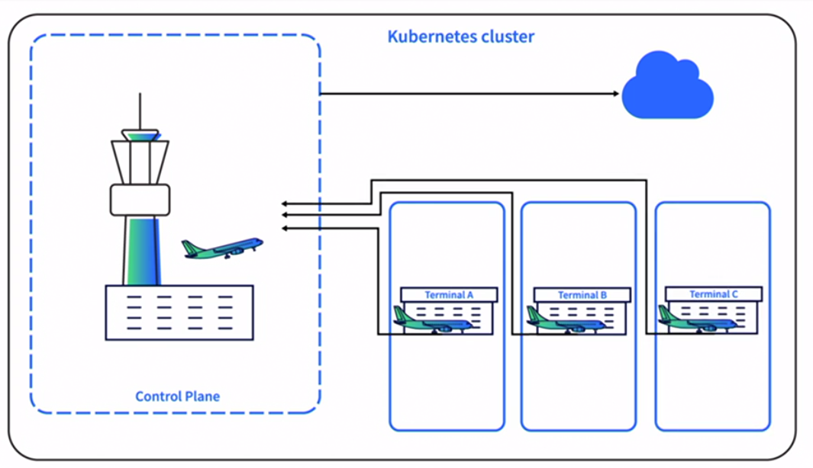

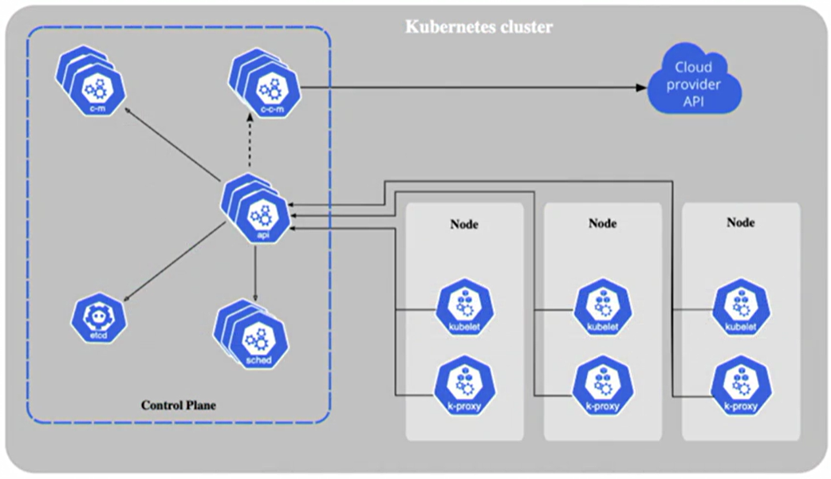

The first component is the Kubelet. The Kubelet is an agent that runs on every worker node, and it makes sure that the containers in a pod have started running and are healthy. The Kubelet communicates directly with the API server in the control plane, and it is looking for newly assigned pods.

The next component is the container runtime. Once the Kubelet has been assigned a new pod, it starts the container or containers using the container runtime interface, or CRI. The CRI enables the Kubelet to create containers with the engines containerd, CRI-O, Kata Containers, and AWS Firecracker. In Kubernetes v1.24, the Dockershim was removed, which means the docker engine can no longer be used as a container runtime, but docker images still work in Kubernetes, because docker images and docker containers are two different things.

The final component of a Kubernetes worker node is the Kube-proxy. The Kube-proxy makes sure that your pods and services can communicate with other pods and services on nodes, and in the control plane. Each Kube-proxy communicates directly with the Kube-APIserver.

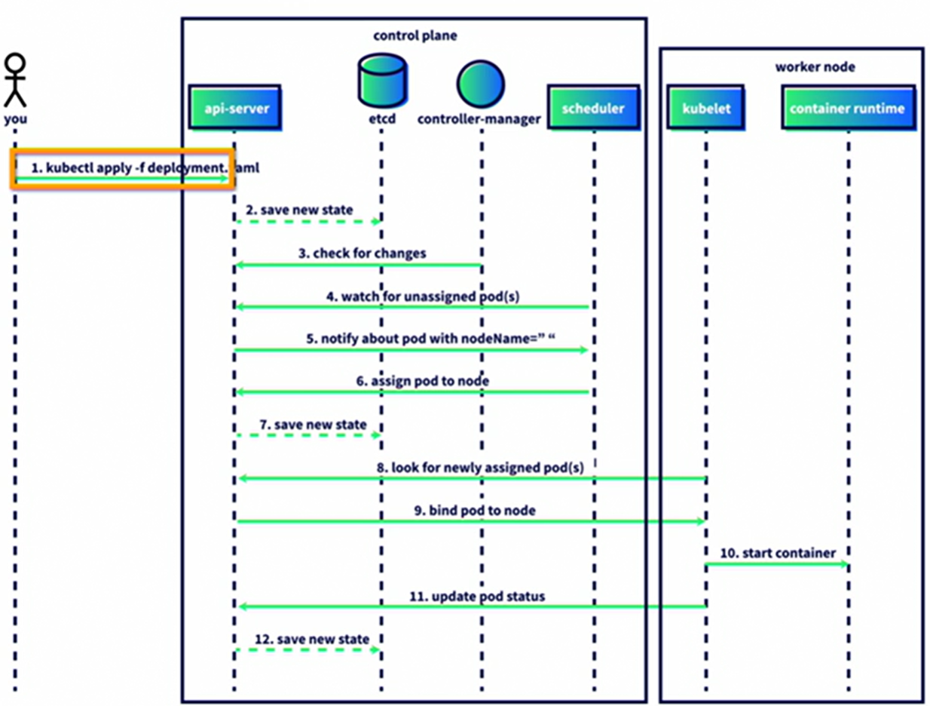

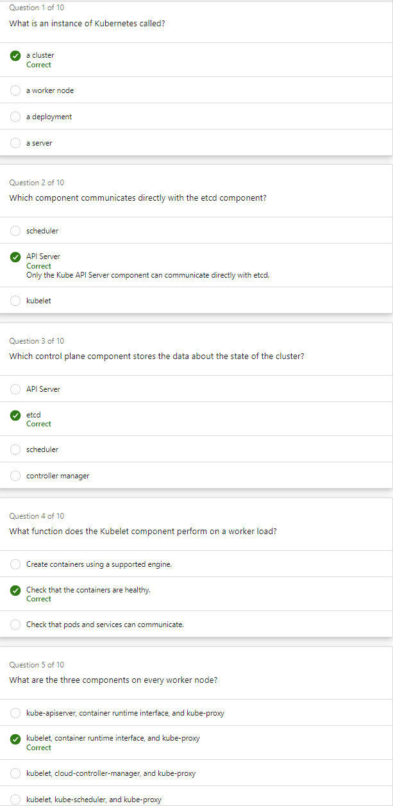 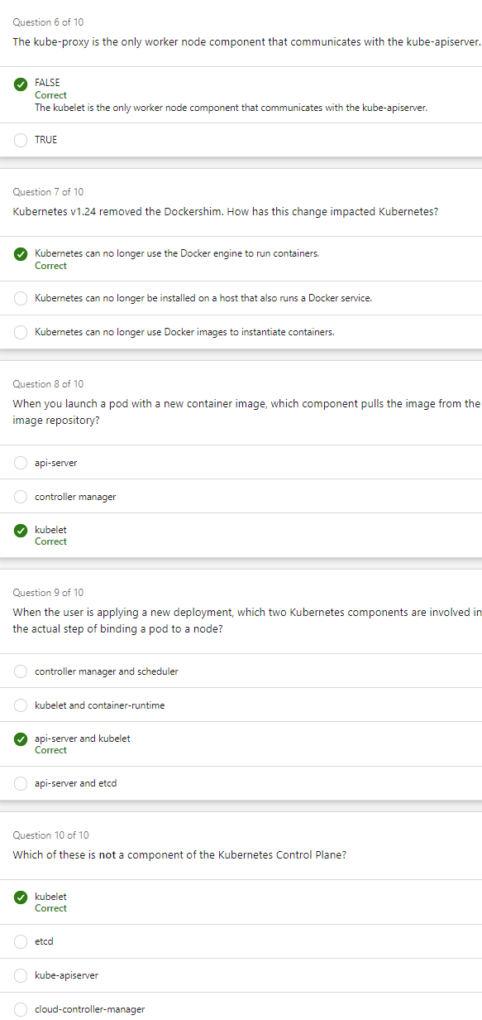

**Ways to manage Kubernetes pods. Deployment, DaemonSet and job.**

The Kubernetes deployment is the most common way to deploy containerized applications.

**Deployments** allow you to control the number of replicas running. When you have a new version of your application and you're ready to deploy it, Kubernetes can keep the old version up and running, roll out the new version, ensure the new pods are running and healthy, and then remove the old pods. This is a no-downtime upgrade, and it's one of the automated features people love best about Kubernetes.

Another way to deploy pods is using a **DaemonSet**. A DaemonSet will put one copy of a container on every node running in the cluster, so you can't directly control the number of replicas running. DaemonSets usually run containers that are agents, or Daemons, running processes in the background. It's common for DaemonSets to run a program that collects metrics about the underlying node and other pods on that node.

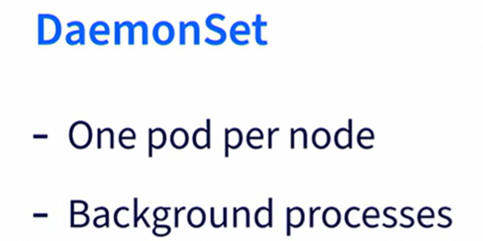

The final way to deploy more than one pod at a time is a Kubernetes **job**. A job will create one or more pods and run the container inside of them until it has successfully completed its task. An example of a Kubernetes job is an application that you deploy in a testing cluster that will generate a batch of data for your testing framework. You only need to generate that data once in a while and you can delete the application once it's done, so a Kubernetes job is the way to go.

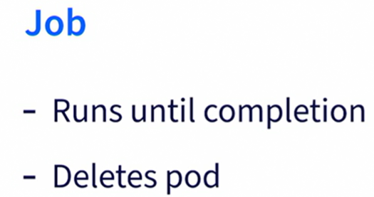

There are a few ways to deploy and manage pods in a Kubernetes cluster, and in this video we covered.

**How do you handle data storage in Kubernetes? In this video, I'll discuss two ways.**

The first option is to **connect your application with a database that is running outside of your cluster**. For example, let's assume you have an application that uses Postgres for data persistence. You can either build and maintain a SQL database on a server that is separate from your cluster, or you can use a managed database service like Azure SQL. Amazon RDS, or Google Cloud SQL and configure it to communicate with Kubernetes.

The second option is to **use a Kubernetes Persistent Volume**. Persistent volumes are a type of data storage that exists in your cluster and remain even after a pod is destroyed. You can use a Kubernetes object called a stateful set to make sure your updated application can communicate with the same volume as the previous pod. Data storage in Kubernetes is a big topic that could have its own course, but you should know that there are two main approaches to making a stateful application work in your cluster. You can set up a database independent of your cluster or you can use Kubernetes Persistent Volumes.

**Kubernetes Security**

Example, three techniques that you can use to secure your cluster right away.

First, add security context info to your containers.

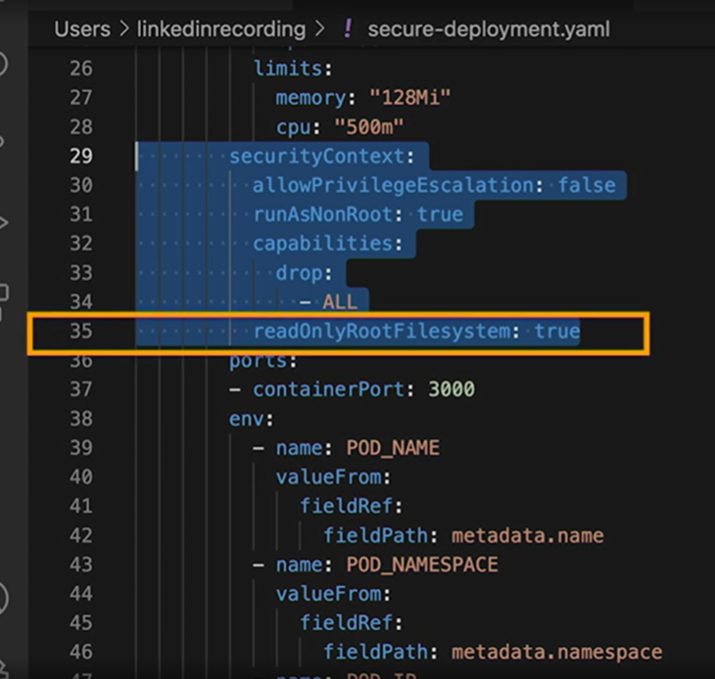

Second, scan your yaml manifests with a tool like Snyk.

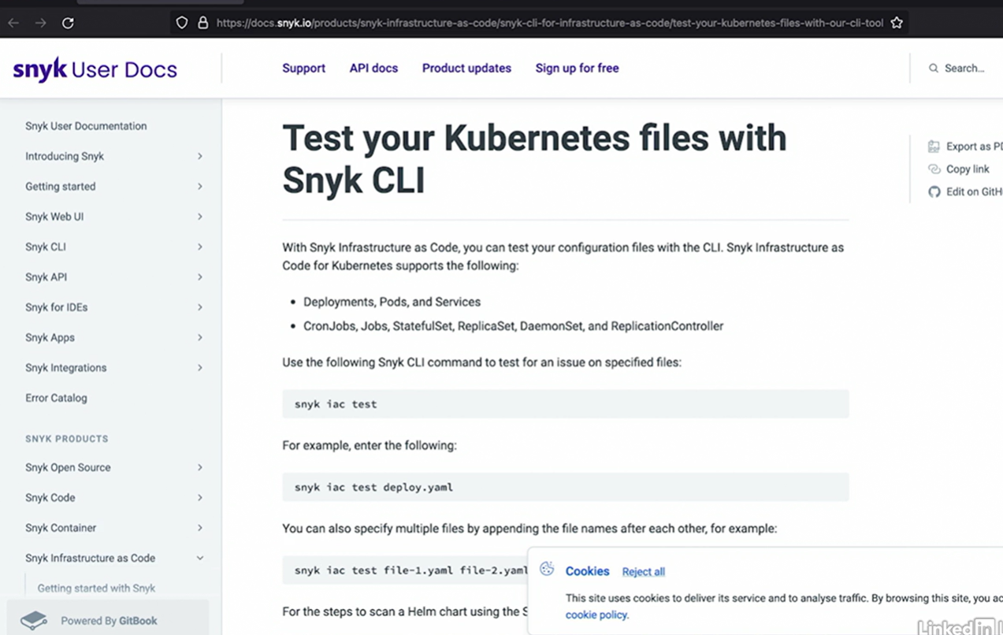

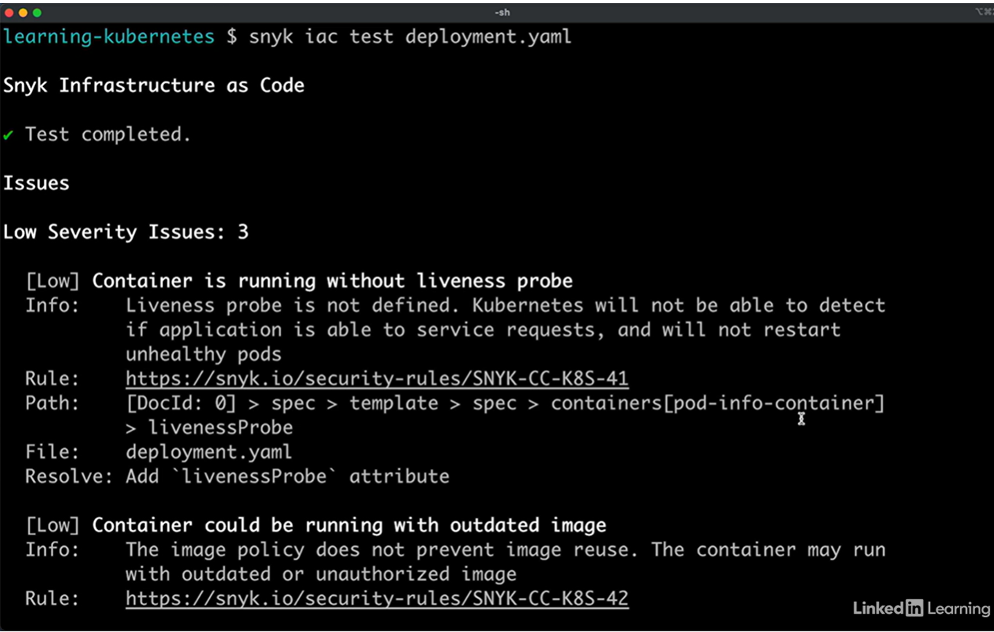

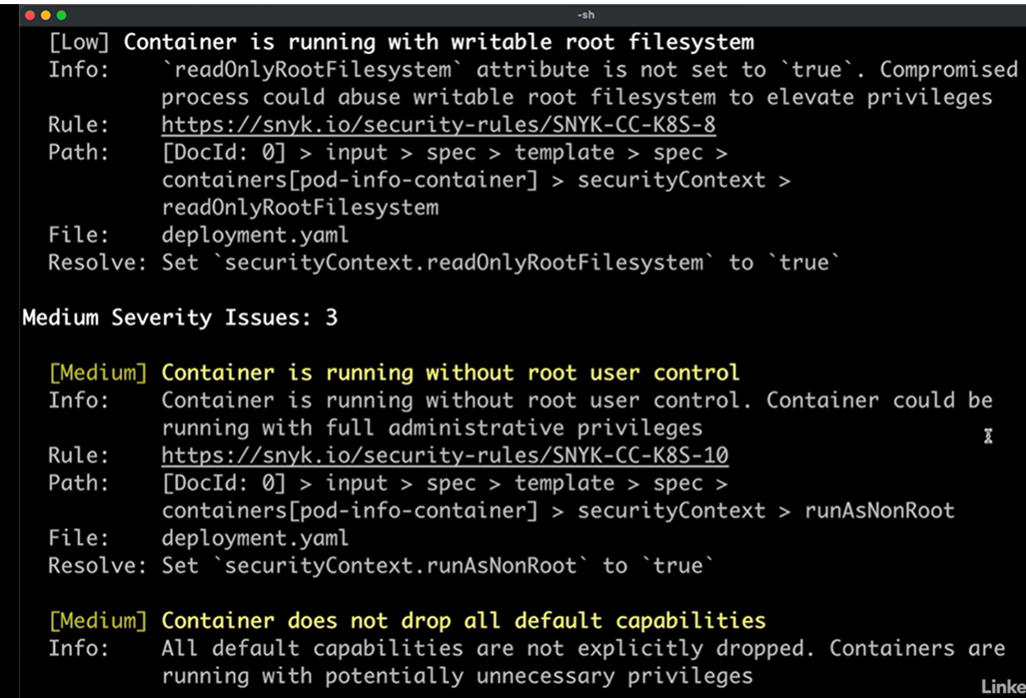

And third, regularly update your Kubernetes version, especially when a security patch is released.

